**Identity and Access Management**

This project is to create an instance, set up an s3 bucket and manage the IAM users.

1.

- Create an IAM user (first name of one of your cluster members) and place it into a group named <<s3group>>.

- The user should have S3 full access/permission only in your account and should be able to reset the password himself at the first login.

- send login credentials (Username, Password & Account ID) to your peer so he/she can login into your account.

Verify if the Policy works:

**The new user should try launching an EC2 instance and let you know if successful or not.**

**Result:** EC2 instance did not work

The new user should try launching an S3 bucket named <<firstname_bucket>> and conclude.

**Result:** S3 Bucket was launched successfully.

2)

- Create an IAM user named "admin" and place it into a group called "admingroup"

- this admin user should have Administrator access and will be used for your day-to-day operation moving forward.

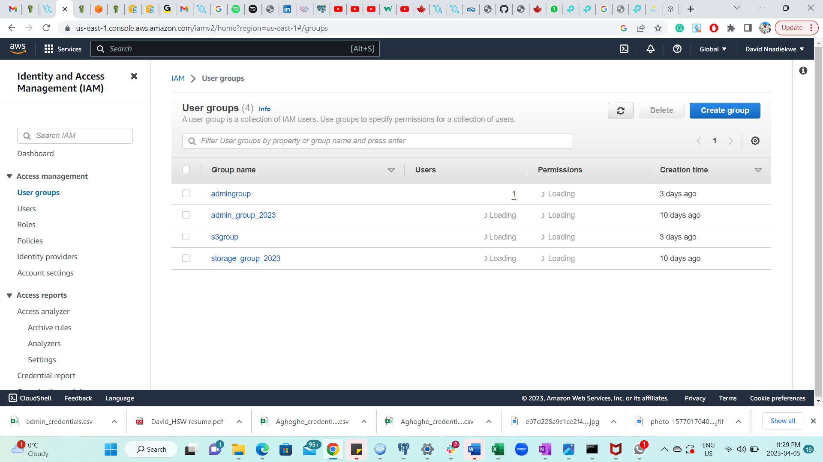

The “admingroup” group created is highlighted in red

- login to the account as admin and make sure you have access to the "billing" service, if not please try to fix the permission issue.

**Result:** Admin has access to “billing” service

1. Create an alias for your aws account

1. Activate MFA for admin user

1. Work with one of your peers to delegate access to each other account using cross-account:

In this exercise, I am account B. I created a role that allowed my cluster member full s3Fullaccess

Cluster member logged in and sent me the screenshots below;

**Result:** Ec2 could not be launched but s3 bucket was successfully launched